What is docker?
What if there is no docker what problem we faced?
How does the does solves the problem?

Why Docker Exists
Before Docker, deploying software was painful. Two core problems kept breaking teams.

Problem 1: "Works on My Machine" 🤯
A developer writes code on their Mac. It runs perfectly. They send it to a teammate on Windows — it crashes. They deploy it to a Linux server — different crash.
Why? Because each machine has:
- Different OS versions
- Different language runtimes (Python 3.9 vs 3.11)
- Different libraries installed at different versions
- Different environment variables and file paths
The code is identical. The environment is not.
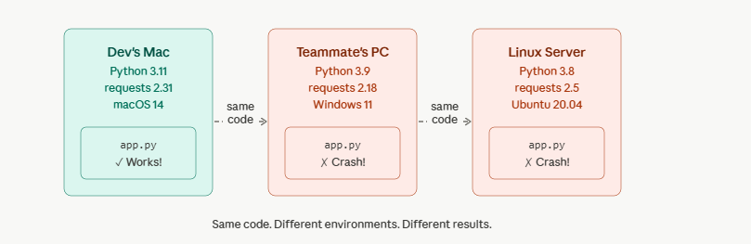
Docker's Solution to Problem 1: Container = Code + Environment
Docker bundles your code and the entire environment it needs into a single portable unit called a container. The container runs identically on any machine that has Docker installed — Mac, Windows, or Linux.
Think of it like a shipping container. Before shipping containers, every port had different loading systems and crates. Shipping containers standardized the box — now the same box works on any ship, truck, or crane worldwide. Docker does the same for software.d
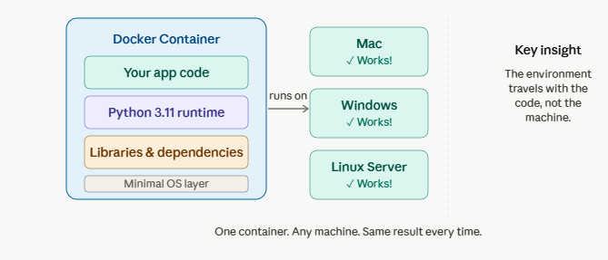
Problem 2: System Setup Issues
Imagine joining a new team. The README says:
"Install Python 3.11,
Node 18,
PostgreSQL 15,
Redis 7, set these 12 env vars, run this migration script…"
Hours later, something still doesn't work because you're on a slightly different OS version. This is the system setup problem:
- Onboarding new developers takes days, not minutes
- Different team members end up with slightly different setups → subtle bugs
- "It worked in staging" but breaks in production because production has a different setup
Docker's solution: Instead of a README full of setup steps, you ship a Dockerfile. Anyone on the team runs docker run and gets an identical, ready-to-go environment in seconds. No manual steps, no version mismatches.

What is a Docker Image?
A Docker Image is the blueprint. A Container is a running instance of that blueprint.
The analogy: an image is like a class in programming, and a container is an object (instance) created from that class. You can run many containers from one image.
An image is built in layers, each representing a step in the build process. Layers are cached, so if only your app code changes, Docker reuses all the previous layers — making rebuilds fast.
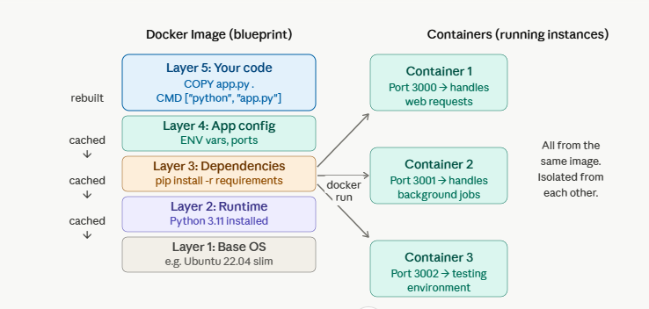
A Real-World Example
Say you're building a Python web app. Your Dockerfile looks like this:
FROM python:3.11-slim # Layer 1+2: OS + Python runtime
WORKDIR /app
COPY requirements.txt .
RUN pip install -r requirements.txt # Layer 3: dependencies
COPY . . # Layer 4: your app code
CMD ["python", "app.py"]
You build this into an image with docker build, then anyone can run it with docker run. They don't need Python installed. They don't need to pip install anything. They just need Docker.

Use Cases in the Real World
Scenario | How Docker Helps
New developer joins team | docker run and they're coding in minutes, not days
App needs Python 3.9 AND 3.11 | Two containers, no conflict — each is isolated
Staging must match production exactly | Same image, deployed to both environments
Running 10 microservices | Each service in its own container, all orchestrated together
Testing a new database version | Spin up a container, test, destroy — no damage to your system

In short: Docker solves the age-old "it works on my machine" problem by making the machine part of the package. An image is the recipe; a container is the meal. And once you have the recipe, you can cook it anywhere.

What id docker container?
Why it replaced vm?
